Chapter 3 Analysis of Pin Jointed Frames

A pin jointed frame (PJF) consists of rod members sustaining only uniform uniaxial stress. They are joined together by frictionless pin joints. Since the entire truss is in equilibrium, each pin must be in equilibrium. For each pin, we can only give two force equilibrium equations as 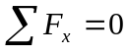 and 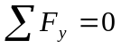. The moment equation 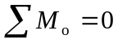 does not work in fact.

3.1 STATICALLY DETERMINATE PJF

The methods used in “engineering statics” are subject to a condition of statical determinacy. It would be helpful to examine the determinacy before solving the problem.

If J denotes the number of pin-joints:
Known 2×J = number of equilibrium equations
Unknown m = number of member forces
r = number of reaction forces

- If m + r = 2J the frame is statically determinate
- If m + r > 2J the frame is statically indeterminate
- If m + r < 2J the frame is a mechanism.

Examples 3.1: To check the determinacy of the following structures.
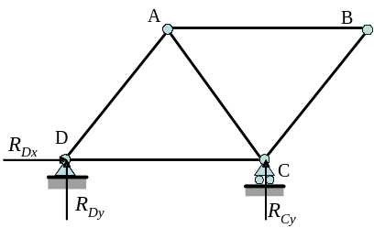
J = 4, m = 5, r = 3
2J = 8
m + r = 8
∴m + r = 2J
This is a statically determinate structure. The internal forces carried by each member can be fully determined by using statics method
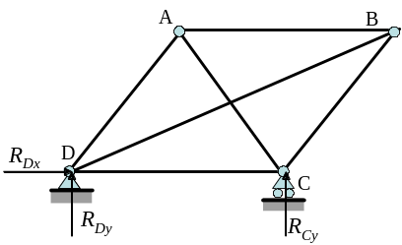

j = 4, m = 6, r = 3
2j = 8
m + r = 9
∴m + r > 2J
This is a statically indeterminate structure.
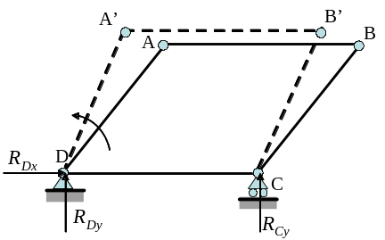

J = 4, m = 4, r = 3
2J = 8
m + r = 7
∴m + r < 2J
This is a mechanism.
Examples 3.2: Check the determinacy of the following structures
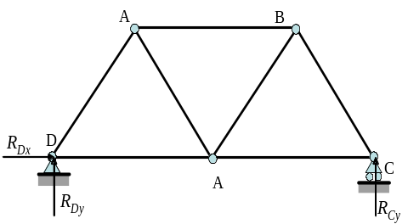

J = 5, m = 7, r = 3
2J = m + r
10 = 7 + 3
This is a statically determinate structure.

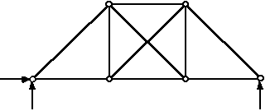
J = 6, m = 10, r = 3
2J = m + r
12 < 10 + 3 = 13
This is a statically indeterminate structure.

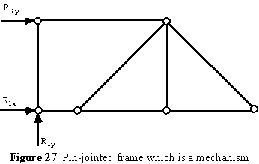
J = 6, m = 8, r = 3
2J = m + r
12 > 8 + 3 = 11
This is a mechanism.

Now that we know how to determine if the pin-jointed frame is statically determinate, we need to find out the force carried by each of the beam members. To do this we can apply one of two analytical methods:

1) Joint Equilibrium
or
2) Method of Sections

You could also use a graphical method known as Maxwell diagram, but that would not give as accurate an answer.

3.2 JOINT EQUILIBRIUM

At each pin joint set up the two equilibrium equations and solve them simultaneously. It is best to start by first evaluating the global equilibrium of the structure (ie; find the required ground reaction forces).

Notation of Internal Forces
Before we begin, however we need to define the notation for a beam experiencing a tensile and compressive force. A tensile force in member is denoted in positive sign and a compressive force in member is represented in negative sign, as shown in Fig. 3.1.
In pin equilibrium, however, we need to look at the reaction from the member. A pin force pointing away from the pin-joint corresponds to a tensile internal force, which is positive.

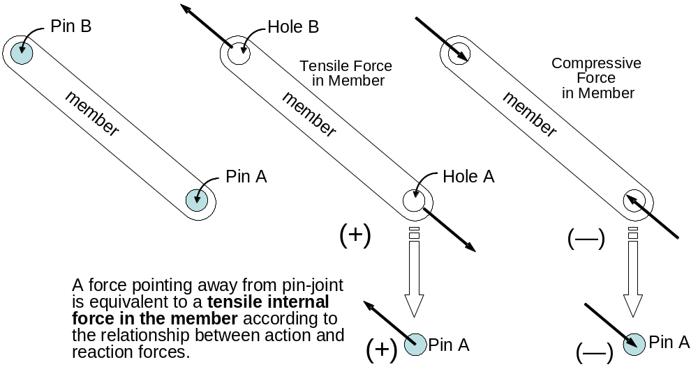

Fig. 3.1 Notation of internal forces

Remark
In order to do this analysis we have to start with a pin-joint that has at least ONE known force and no more than 2 unknown forces.

Example 3.3: Determine the internal forces carried by all the beams in the following pin-jointed frame (all angles are 45º or 90º and the length of AB is L).
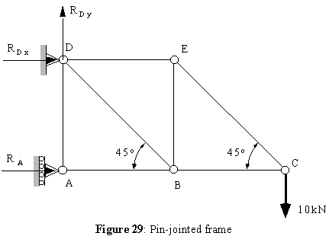

Step 0: Determinacy
J = 5, m = 7, r = 3
2J = m + r
10 = 7 + 3
This is a statically determinate structure and can be solved through the method of pin equilibrium.

Step 1: Global Equilibrium

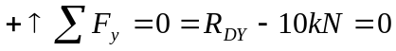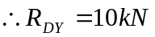
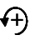
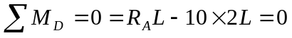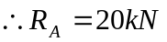
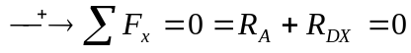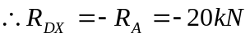

Step 2: Pin-Joint Equilibrium
Let’s start with Pin-Joint C: Because we don't know the direction of forces F_{EC} and F_{BC} we assume them to be positive, hence the arrow which describes them has to point away from the pin-joint.

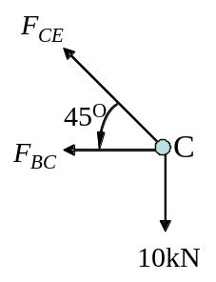
Pin-Joint Equilibrium at C
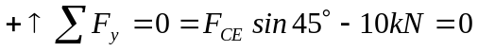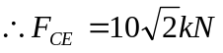
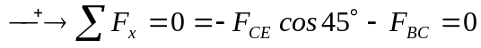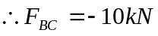

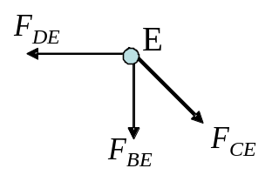
Pin-Joint Equilibrium at E:
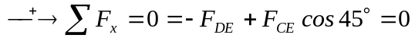
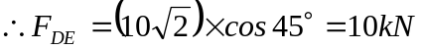
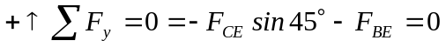
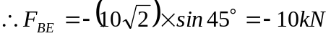
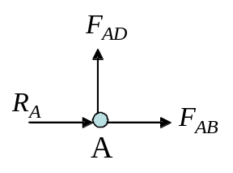
Pin-Joint Equilibrium at A:
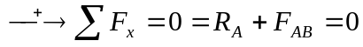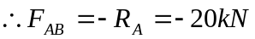
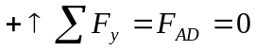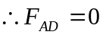

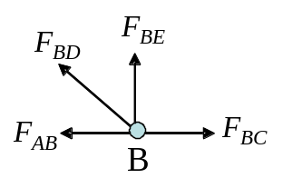
Pin-Joint Equilibrium at B:
Although we’ve known that F_{BC} and F_{AB} are in compression, we can still draw them in the positive directions and then substitute their values together with the negative signs to the equilibrium equations.
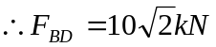
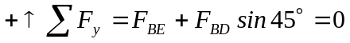
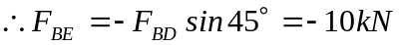 (Checks)

Step 3: Tabulate the Results

member | F_{i} (kN) | Behavior
CE | 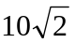 | Tension
BC | -10 | Compression
BE | -10 | Compression
DE | 10 | Tension
BD |  | Tension
AB | -20 | Compression
AD | 0

3.3 METHOD OF SECTIONS

Cut the FBD of the pin jointed frame through 3 or less members, then use the three equilibrium equations of statics.

Example 3.4: Using the structure of example 3.3, determine the forces carried by members DE, DB, and AB.
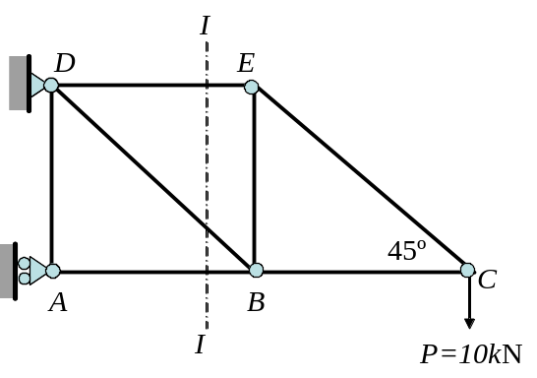
Instead of solving for all the forces we just cut through those three beams and draw a new FBD. We can draw a FBD of the left hand side or of the right hand side, it really makes no difference which one you decide to analyse, both will give you the same answer.

For this example we will analyse the RHS.

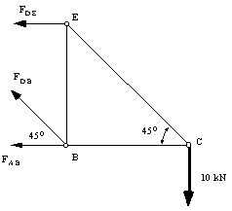
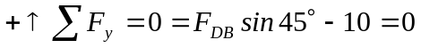
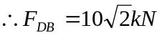
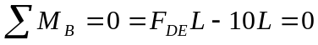
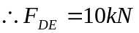
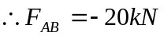

3.4 STRAIN ENERGY AND WORK

Work Done by Force
The work (W) done on an elastic body by applied forces (P) is fully accumulated inside of it in the form of strain energy (U).

What actually happens is as follows, as you apply forces onto a structure it is going to deform elastically. This deformation, combined with the applied forces gives you a measure of the work done on the structure. Now because the structure is made from an elastic material, this deformation causes the structure to store the work as energy, to be specific, Strain Energy.

To derive the strain energy term, let’s look at a small element of size dx×dy×dz, with an applied normal stress σ_{z}.
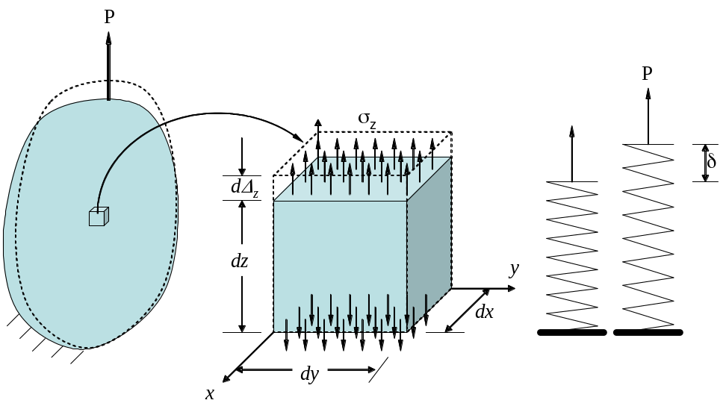

Fig. 3.2 Strain energy in a differential element

Resultant Force of differential element
The force developed in the top and bottom surfaces due to the applied stress is:
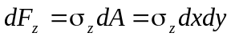 (3.1)

Deformation
The deformation due to the resultant differential force is:
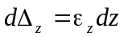 (3.2)
We are only considering structures made from materials with linear elastic behavior. So plotting a diagram of applied force vs displacement gives:
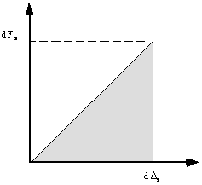
Fig. 3.3 Diagram of force vs displacement for the differential element

The work done on this differential element by the applied force is defined as the area underneath this diagram, such that:
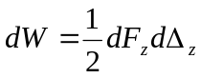 (3.3)
But this process is isentropic (reversible), meaning that the Strain Energy must be equal to the applied Work, so W=U.

Relationship between Work and Strain Energy
So for our small volume, the elemental work is equal to the elemental strain energy:
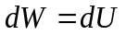 (3.4)
Substituting these 4 equations together we obtain :
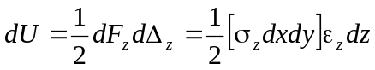
But since the volume of this element is :
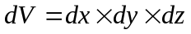
then equation (d) becomes:
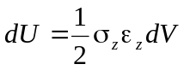 (3.5)
An important relationship can be found from Eq. (3.5), if we compare it with a stress strain diagram for the small element.
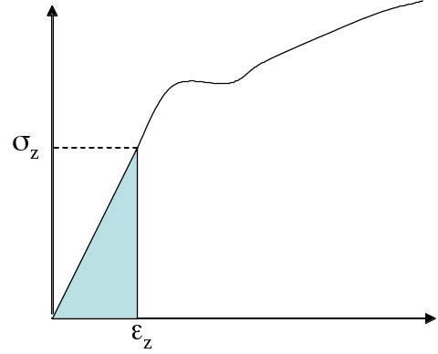
Fig. 3.4 Stress-strain diagram for the differential element

Because the structure is made of a linear elastic material, then the stress strain diagram looks like this:

Strain Energy
Therefore: 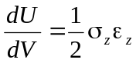 ― Strain-energy per unit volume =Strain Energy Density
The term 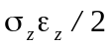 is the area underneath the stress-strain diagram (Fig. 3.4) and is called the Strain-Energy Density. It is a measure of the strain energy stored in the structure per unit volume.
Mathematically can the strain energy density be written like this:
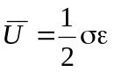 (3.6)

Modulus of resilience U_{r} ―When stress reaches the proportional limit, strain energy density is referred to Modulus of resilience U_{r} as
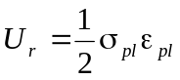 (3.7)

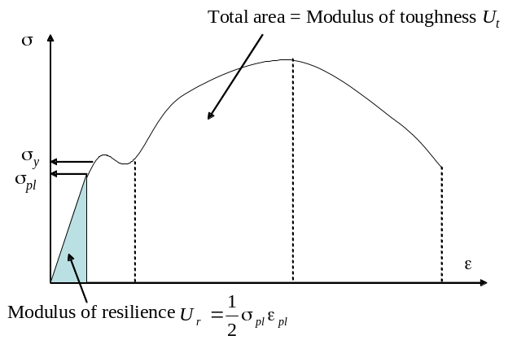
Fig. 3.5 Modulus of resilience 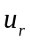and modulus of toughness

Modulus of toughness U_{t} ― This property becomes important when designing member is accidentally overloaded. The higher the modulus of toughness, the more strain energy can be stored (absorbed) inside the material before fracturing

Total Strain Energy inside deformable body
Equation (3.5) is the elemental strain energy, by integrating it w.r.t. the total volume and substituting Hook's law we have that:
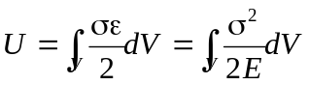 (3.8)

3.5 STRAIN ENERGY UNDER AXIAL LOADING

Let’s look at a general case of bar under an axial loading as illustrated in Fig. 3.6. Assume the internal force F(x) at a cross-sectional area A(x) located at a distance x from end B. Assume that the normal stress σ_{x} is uniformly distributed over any transverse section.
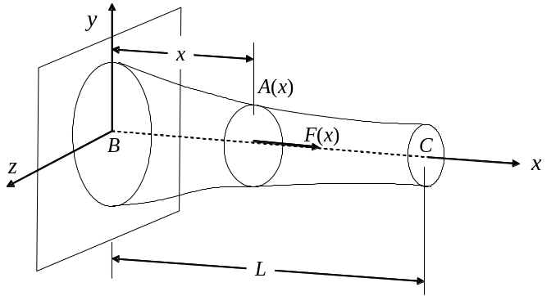
Fig. 3.6 Strain energy for a bar under axial loading

General Cases
Average normal stress 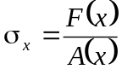
Substituting for σ_{x} into Eq. (3.8), we have the Total Strain Energy as:
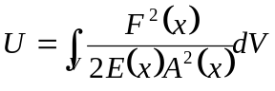 (3.9)
But 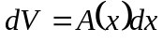, therefore
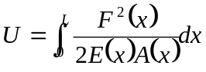 (3.10)

Uniform rod
If 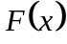 = constant, 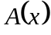 = constant, 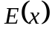 = constant (homogeneous material) as shown in Fig. 3.7, we can rewritten Eq. (3.10) as
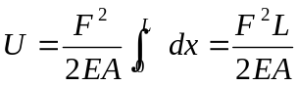 (3.11)

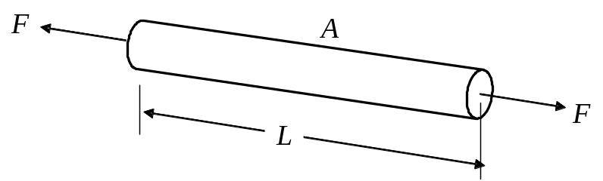
Fig. 3.7 Strain energy for a uniform bar

Example 3.5: A circular shaft consists of two portions BC and CD of the same material and same length, but of different cross sections. Determine the total strain energy of the shaft when it is subjected to a centric axial load P, expressing the result in terms of P, L, E, the cross-sectional area A of portion CD and the ratio n of the two diameters.

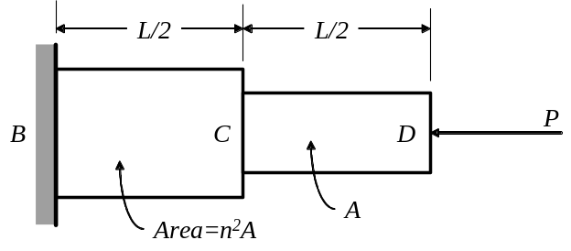
We use Eq. (3.11) to compute the strain energy of each of the two portions and add the expressions obtained the total strain energy as
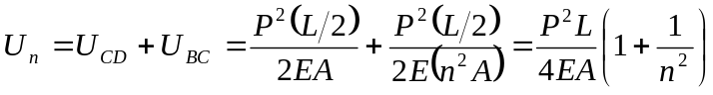
or 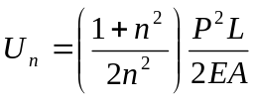
We check that, for n =1, we have 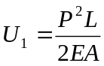, which is the expression given in Eq. (3.11) for a rod of length and uniform cross-section area A. We also note that, for n>1, we have U_{n} < U₁; for example, when n = 2, we have 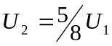. Since the maximum stress occurs in portion CD, it follows that for a given allowable stress, increase the diameter of portion BC will result in a decrease of overall energy-absorbing capability of the rod. So unnecessary changes in cross-sectional area should avoided in design of structure, where the energy-absorbing capability is critical.

3.6 DEFLECTION UNDER A SINGLE CONCENTRATED LOAD
BY THE WORK-STRAIN ENERGY METHOD

Problem 1

If the deflection Δ₁ of a structure or member under a single concentrated load P₁ is known, the corresponding Work W may be obtained by writing
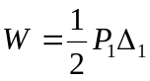 (3.12)
The total work done by the external load P₁ will be fully stored in the structure.

Problem 2
Conversely, if the strain energy U of a structure or member subjected to a single concentrated load P₁ is known, by using energy conservation as W = U, we can determine the deflection under such a single load
W = U (External Work = Internal Strain Energy) (3.13)
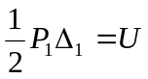
Therefore, we have: 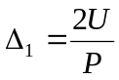 (3.14)

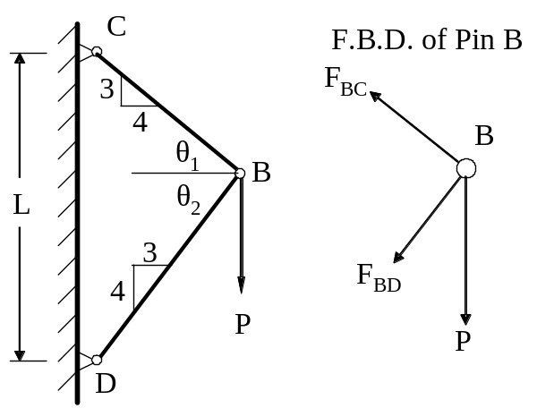
Example 3.6: A load P is supported at B by two rods of the same uniform cross-sectional area A. Determine the vertical deflection of point B

Step 0: Geometric parameters
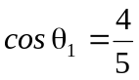, 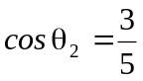
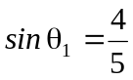, 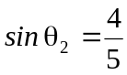
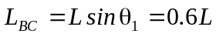,
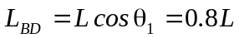

Step 1. Internal Forces carried by Members

Pin-Joint Equilibrium Method
we have
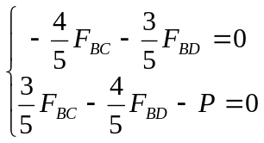
Thus 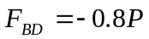, 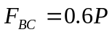

Step 2. Total Strain Energy
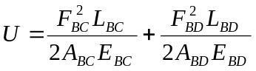
Therefore
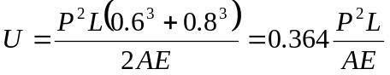

Step 3. Deflection from Work-Energy Method
External Work done by P: 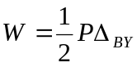
Total Strain Energy: 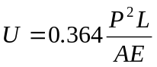
From the Conservation of Energy 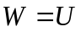, we have
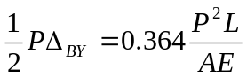
Thus: 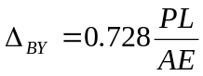 ANS

Remarks
It should be noted that, once the internal forces in the two rods have been obtained, the deformations δ_{BD} and δ_{BC} (elongation or contraction) can be computed. Determining the vertical deflection at point B from these deformations, however, would require a careful geometric analysis of various displacements involved. The strain energy method used here makes such an analysis unnecessary and significantly simplifies the problem.

Example 3.7: Members of the truss shown consist of sections of aluminum pipe with the cross-section areas indicated. Using E=70GPa, determine the vertical deflection of point E caused by the load P.

Step 0: Basic Parameters
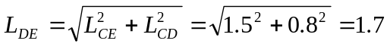; 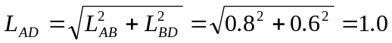
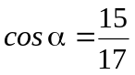, 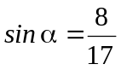; 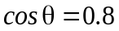, 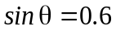
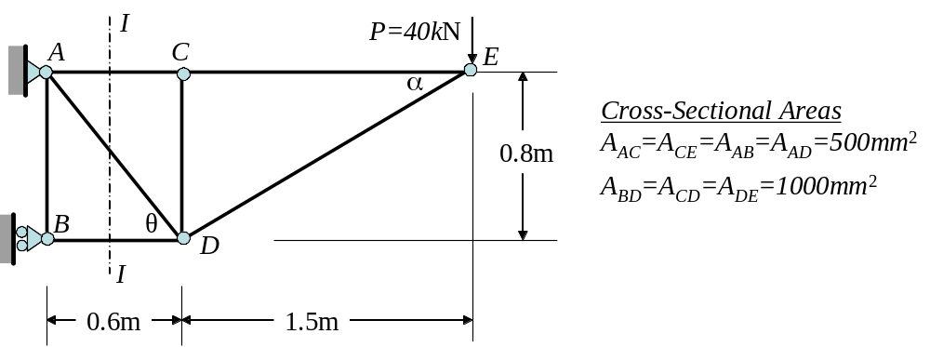

Step 1: Internal Forces
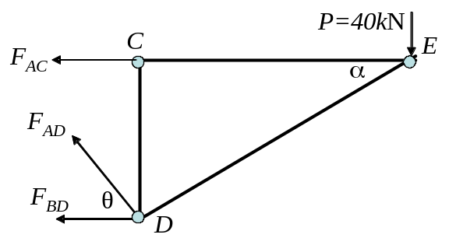
Method of Section (I-I)
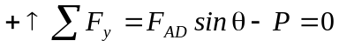
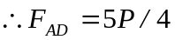
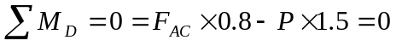
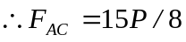
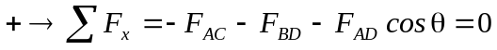
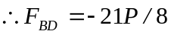

Pin-Joint Equilibrium E

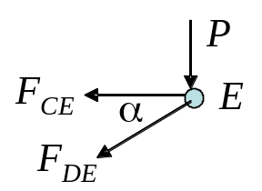
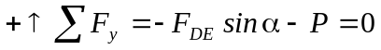
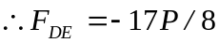
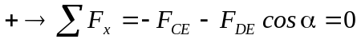

Pin-Joint Equilibrium B
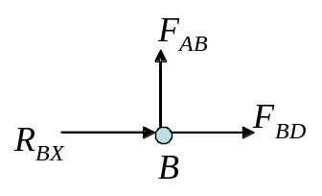
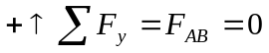
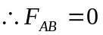

Pin-Joint Equilibrium C
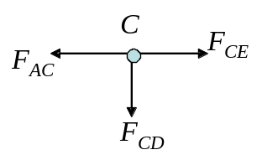
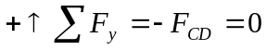
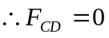

Step 2: Total Strain Energy
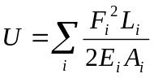

Member | F_{i} (N) | L_{i}(m) | A_{i} (m²) | 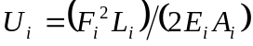
AB | 0 | 0.8 | 500×10⁻⁶ | 0
AC | 15P/8 | 0.6 | 500×10⁻⁶ | 4219P²/2E
AD | 5P/4 | 1.0 | 500×10⁻⁶ | 3125P²/2E
BD | -21P/8 | 0.6 | 1000×10⁻⁶ | 4134P²/2E
CD | 0 | 0.8 | 1000×10⁻⁶ | 0
CE | 15P/8 | 1.5 | 500×10⁻⁶ | 10547P²/2E
DE | -17/8 | 1.7 | 1000×10⁻⁶ | 7677P²/2E

From the summation of the last column, we have the total strain energy as
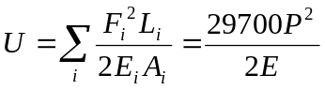

Step 3: Principle of Work ― Strain Energy
We recall the work done by the force P as it is gradually applied is 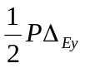. Equating the work done by P to the total strain energy U and recalling that E = 70GPa and P=40kN, we have
W = U
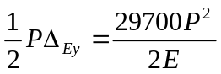
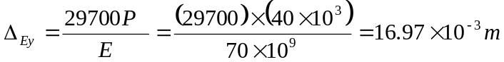
Therefore:
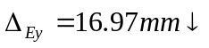 (“+” stands for the same direction as load P)

Remarks
Work―Strain Energy is efficient for determining the deflection. However, it is effective only when
- there is a single load; and
- the unknown deflection is at the loading point and along the same direction as load P.

3.7 DEFLECTION UNDER MULTIPLE LOADS
― CASTIGLIANO’S SECOND THEOREM

In order to derive Castigliano’s second theorem, we consider two loading sequences:

Sequence 1
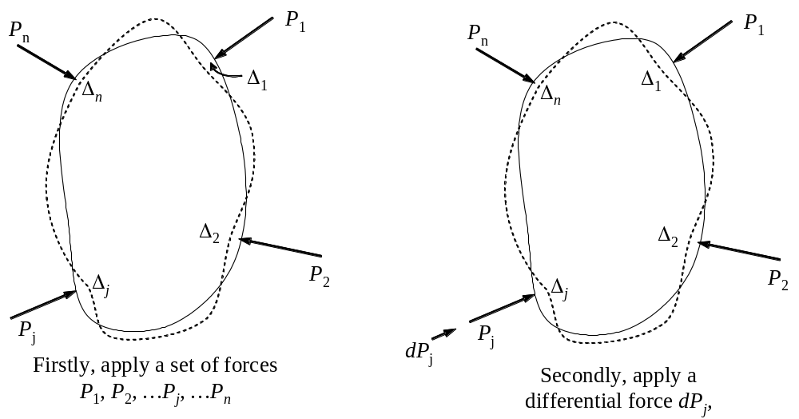
Fig. 3.8 Loading Sequence 1

First step, apply a set of force (P₁, P₂, …P_{j}, …P_{n}) onto the elastic body. Suppose that only linear elastic deformation is considered. By the end of the first step, the external work done by the force set will be
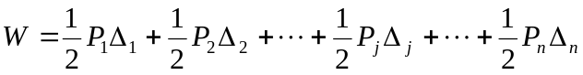
i.e.
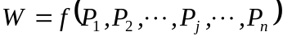 (3.15)
The work done by such n forces will be fully stored inside the body in a form of strain energy, i.e.
(3.16)

Second step, increase one of those external forces, e.g. P_{j} by a differential amount dP_{j} . The new total strain energy inside the elastic body will become
According to integral calculus, we can express the new energy as
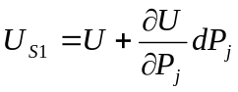 (3.17)

Sequence 2
We are going to reverse the load sequence.
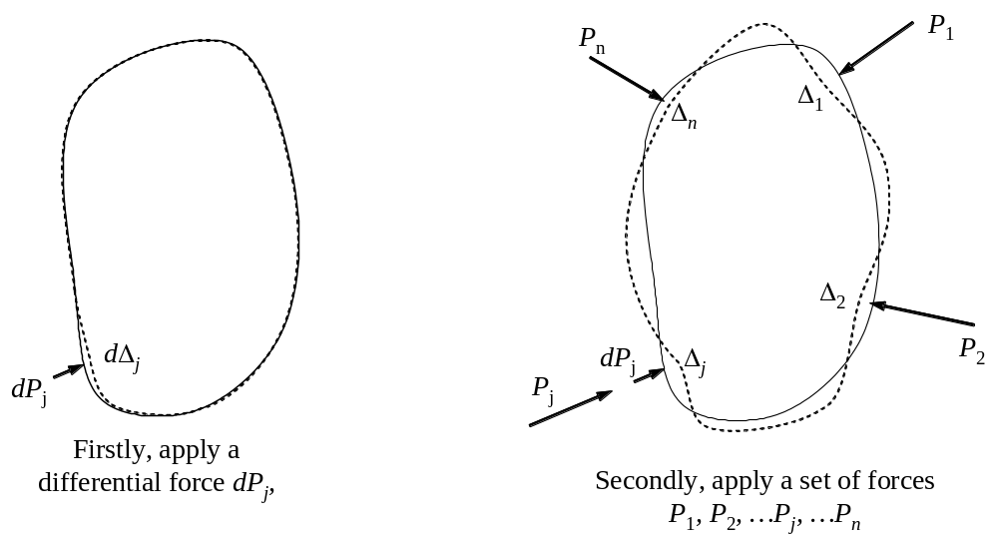
Fig. 3.9 Loading Sequence 2

First step Apply a differential force dP_{j} onto the body, which cause the body to deform by a differential amount dΔ_{j}. The work done by the differential force should be
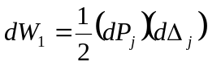 (3.18)
Second step Apply a set of forces (P₁, P₂, …P_{j}, …P_{n}) onto the elastic body. The work done at this loading step should be computed as
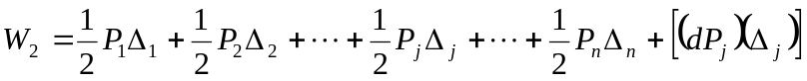 (3.19)
It is worth noting that since force (P₁, P₂, …P_{j}, …P_{n}) cause the jth loading point move by Δ_{j,} the work done by dP_{j} needs to be taken into account as 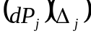, where the differential force dP_{j} does not change.

Adding Eqs. (3.18) and (3.19) gives the total external work done by the forces in Sequence 2 as
Neglecting the second-order differential, and referring to Eq. (3.16), we have
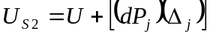 (3.20)

However, the strain energy should not depend on the loading sequences. Therefore,
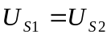 (3.21)
Substituting Eq. (3.17) and (3.20) into Eq. (3.21) gives
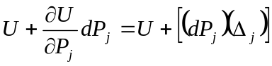
Thus
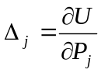 (3.22)

Castigliano’s 2nd theorem, Eq. (3.22), states that displacement Δ_{j} in the direction of P_{j} is equal to the first partial derivative of the total strain energy with respect to P_{j}.

Castigliano’s theorem applied to truss
In a truss structure, the total strain energy can be often expressed as
The displacement can be thus computed as
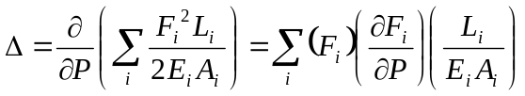 (3.23)
In order to determine the partial derivative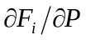, it will be necessary to treat external load P as a variable, not a specific numerical quantity. In other words, each internal force F_{i} must be expressed as a function of P.

Virtual load in Castigliano’s theorem
It is worth point out that the unknown deflection Δ_{j} at a given point j can be obtained by direct application of Castigliano’s theorem ONLY IF a load P happens at j in the direction in which Δ_{j} is to be determined. When no load is applied at j, or when a load is applied in a direction other than the desired one, we may still obtain the deflection Δ_{j} by Castigliano’s theorem. We firstly apply a virtual (fictitious) load Q_{j} at j in the direction in which the deflection Δ_{j} is to be determined and then use Castigaliano’s theorem to obtain the deflection as
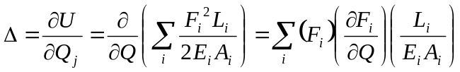 (3.23)

in which the internal forces should be found in terms of both real load P and virtual load Q_{j}. In other words, internal force F_{i} would be a function of both P and Q_{j}. After finding out all the partial derivatives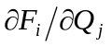, we then make 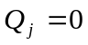.

Example 3.8: As in Example 3.6, a load P is supported at B by two rods of the same uniform cross-sectional area A. Determine the vertical and horizontal deflections at point B

Step 0: Geometrical parameters
, ; ,
;

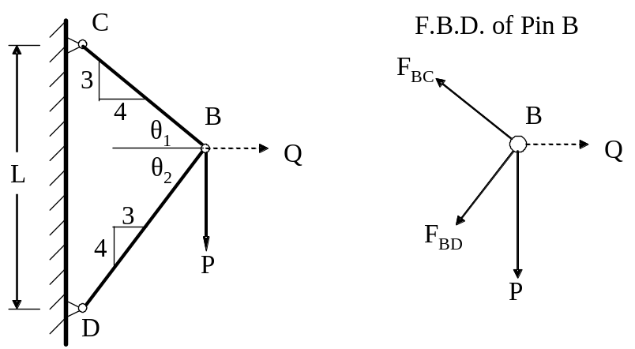

Step 1: Apply a virtual load Q at B in order to find unknown deflection 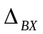
A “real” load has been applied at point B along vertical direction. So Castigliano’s theorem can be directly used to determine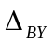. However, since there is no horizontal force at point B, we cannot directly compute the deflection . For this reason, a virtual load Q is necessary.

Step 2 Internal forces due to real load P and virtual load Q
Pin-Joint Equilibrium at B
we have (assume that Q is known)
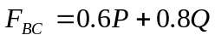; 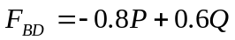

Step 3 Total Strain Energy
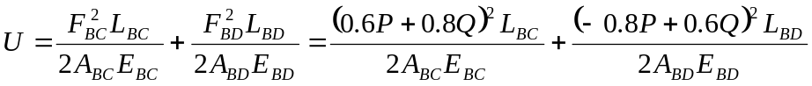

Step 4 Castigliano’s Theorem
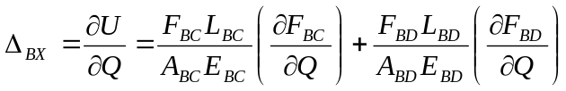
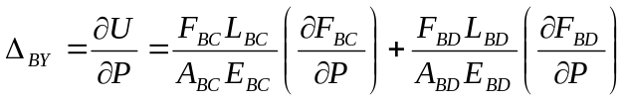

Computing the partial derivatives
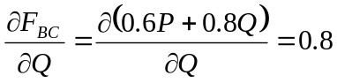; 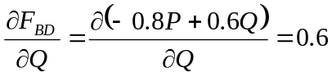
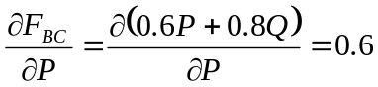; 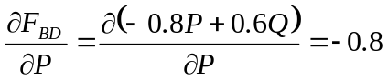

Substituting these partial derivatives into the previous equations, we have
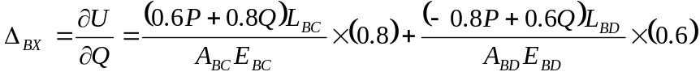
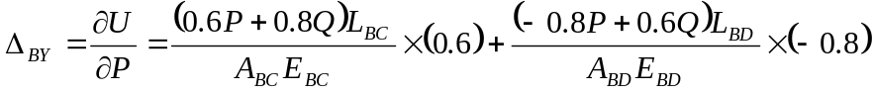

In fact, Q is a fictitious load and does not exist at all, so we make Q = 0, thus
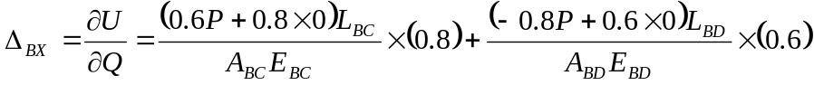
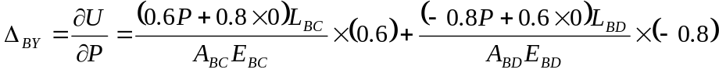
i.e.
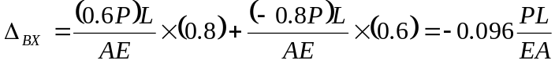
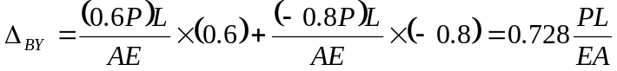
Finally we have,
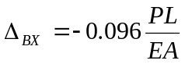 (- stands for the opposite direction to the assumed virtual load Q)
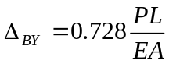 (+ stands for the same direction as real load P)

Example 3.9: As in Example 3.7, determine the vertical deflections at point C.
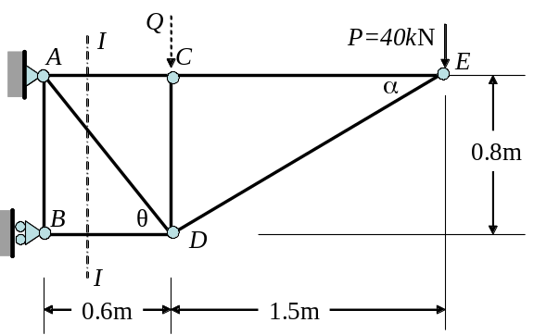

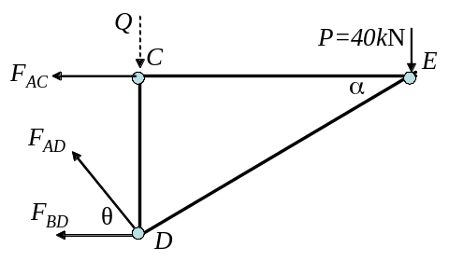

Step 1: Apply a virtual load Q at C in order to find unknown vertical deflection 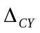
Since there is no external load applied at point C, we cannot directly use Castigliano’s theorem to compute the deflection . For this reason, we have to apply a virtual load Q at C along vertical direction.

Step 2 Internal Force due to real load P and virtual load Q
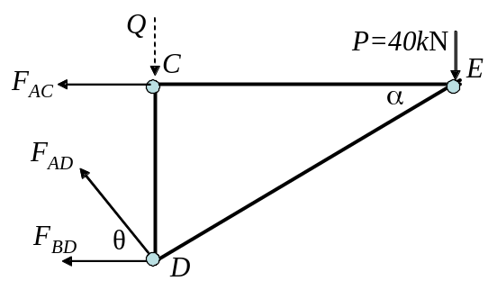
Method of sections (I-I)
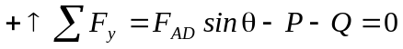
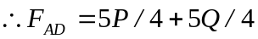
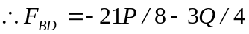
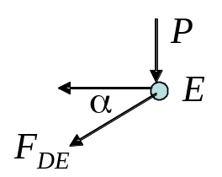
Pin-joint equilibrium at E
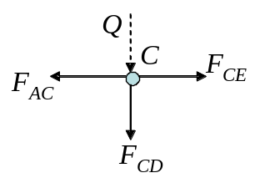

Pin-joint equilibrium at E
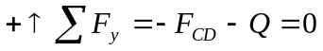
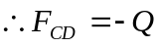
Similarly to Example 3.7, from Pin-Joint equilibrium B we can have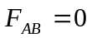.

Step 3: Total Strain Energy
Step 4: Castigliano’s Theorem
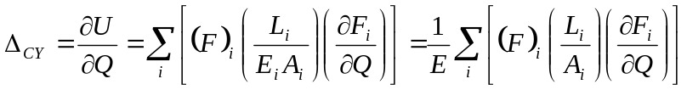

Member | F_{i} (N) | 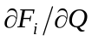 | L_{i}(m) | A_{i} (m²) | 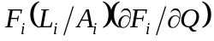
AB | 0 | 0 | 0.8 | 500×10⁻⁶ | 0
AC | 15P/8 | 0 | 0.6 | 500×10⁻⁶ | 0
AD | 5P/4+5Q/4 | 5/4 | 1.0 | 500×10⁻⁶ | 3125P+3125Q
BD | -21P/8-3Q/4 | -3/4 | 0.6 | 1000×10⁻⁶ | 1181P+338Q
CD | -Q | -1 | 0.8 | 1000×10⁻⁶ | 800Q
CE | 15P/8 | 0 | 1.5 | 500×10⁻⁶ | 0
DE | -17/8 | 0 | 1.7 | 1000×10⁻⁶ | 0

From the summation of the last column, we have:
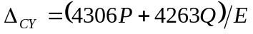
Since Q is not part of the original loading, we set Q = 0 and have
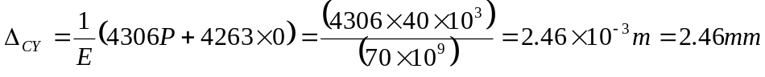 ANS
(“+” stands for the same direction as applied virtual load Q, i.e. )

